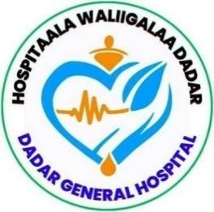

DEDER GENERAL HOSPITAL
HEALTHCARE QUALITY IMPROVEMENT PROJECT
REDUCING READMISSION RATE

By: MEDICAL WARD QI TEAM

Written BY:
- Abdi Tofik (BSc, MPH)-HSQ Quality Director
- Hamza Jemal (BSc N)-Matrone

June 2017E.C,
Deder, Eastern Ethiopia

TABLE OF CONTENTS
LISTS OF QI TEAM MEMBERS ii
INTRODUCTION 1
ORGANIZATION’S MISSION AND VISION, 2
PROBLEM IDENTIFICATION AND PRIORITIZATION MATRIX 3
PROBLEM STATEMENT 4
AIM STATEMENT 4
List of interventions/change ideas selected by prioritization matrix for testing 7
MEASURES/INDICATORS 8
IMPLEMENTATIONS OF PLAN OF PDSA 9
Outcome Measure data collection plan 10
Process Measurements data collection plan 10
Process Measurements Performance Tracking sheet 11
RESULTS 13
DISCUSSION 15
LESSONS LEARNT 16
CONCLUSION 17
REFERENCES 18

Figure 1:fishbone diagram to reduce the readmission rate from the current 12% to less than 5% from January 2017E.C to June 2017E.C 5
Figure 2: Driver diagram to reduce the readmission rate from the current 12% to less than 5% from January 2017E.C to June 2017E.C 6
Figure 3: Run chart with Multiple PDSA to reduce the readmission rate from the current 12% to less than 5% from January 2017E.C to June 2017E.C 14

S/N | Full Name | Profession | Status | Role
 | Dr. Dawit Seifu | GP | Inpatient Director | QI project leader
 | Hamza Jemal | BSc N | Matron | Co-leader
 | Abdurrahman Shame | BSC N | Medical Ward Head | Secretary
 | Dine Mohamed | BSC N | Mw Staff | Member
 | Muluqan Tasfaye | BSC N | Mw Staff | Member
 | Abrahim Mohamed | BSC N | Mw Staff | Member
 | Calaa Abrahim | BSC N | Mw Staff | Member
 | Bayan Mohammadnur | BSC N | Mw Staff | Member

LISTS OF QI TEAM MEMBERS

INTRODUCTION
Readmission rates are a critical metric reflecting healthcare quality. Globally, unplanned readmissions are prevalent, with approximately 20% of patients in countries like the United States being readmitted within 30 days of discharge. Conditions such as heart failure, chronic obstructive pulmonary disease (COPD), and diabetes significantly contribute to these rates. This issue poses a financial burden on healthcare systems, accounting for billions of dollars in annual costs.
In Africa, the readmission rate varies but remains a challenge due to resource limitations. For instance, studies have highlighted that comorbidities, inadequate discharge planning, and follow-up care gaps drive high readmission rates. Heart failure patients in Sub-Saharan Africa often face rates exceeding global averages, compounded by factors like rural residency and low socioeconomic status.
In Ethiopia, research indicates similar concerns. A retrospective cohort study among heart failure patients revealed significant predictors of readmissions, including advanced age, comorbidities, and anemia. Another study in Ethiopia focusing on COPD and asthma found that 20% of patients experienced unplanned readmissions within 30 days, emphasizing the need for targeted interventions to address these clinical and socioeconomic challenges
This QI initiative aims to identify and address root causes of long outpatient waiting times and implement targeted interventions to reduce the time patients spend waiting for consultation.

ORGANIZATION’S MISSION AND VISION,
- ERGAMA (MISSION):
- To reduce morbidity, mortality and disability, and
- To improve the health status of the people in catchment area through providing and regulating a comprehensive package of preventive, promotive, rehabilitative and basic curative health services via a decentralized and democratized health system.
- MUL’ATA (VISION):
- We aspire to see healthy, productive and prosperous people of catchment area.
- “To be a leading healthcare facility recognized for excellence and innovation in patient care.”

PROBLEM IDENTIFICATION AND PRIORITIZATION MATRIX
Sno | Problems | Magnitude | Severity | Feasibility | Gov’t  Concern | Community  Concern | Total | Rank
1 | Low medical record | 5 | 3 | 8 | 5 | 5 | 31 | 4th
2 | Low implementation of OPD  appointment system | 7 | 8 | 7 | 6 | 3 | 31 | 4th
3 | High readmission rate | 8 | 8 | 9 | 10 | 8 | 43 | 1st
4 | >24 hour patient staying  time at emergency | 5 | 6 | 6 | 8 | 3 | 28 | 6th
5 | Poor protocol adherence | 7 | 8 | 8 | 9 | 3 | 35 | ₃rd
6 | High ICU mortality rate | 5 | 6 | 3 | 8 | 8 | 30 | ₅th
7 | Inadequate Teamwork and  Communication | 8 | 9 | 8 | 8 | 9 | 42 | ₂nd
Rating Scale; Minimum = 28, Maximum = 43

PROBLEM STATEMENT
Data collected from the Medical Ward Inpatient Registry from July 2016E.C to December 2017E.C show that 12% of discharged patients experience an unplanned readmission, which can increase healthcare costs, lead to poor health outcomes, and reduce quality of life. Additionally, high readmission rates can overwhelm healthcare facilities, exacerbating issues such as overcrowding and limited capacity to serve new patients. More broadly, readmissions indicate inefficiencies in care delivery, highlighting systemic issues in care transitions and patient engagement.

AIM STATEMENT
We Deder General Hospital Medical Ward QI team aim to reduce the readmission rate from the current 12% to less than 5% from January 2017E.C to June 2017E.C

FISHBONE DIAGRAM



PROCESS
Lack of communication between inpatient and liaison office
PATIENT
Insufficient Post-Discharge Follow-up

Inadequate Discharge Planning
PROVIDER
LEADERSHIP
No M&E

No effective MDT round
No Risk Stratification method
Comorbidities and Complex Medical Conditions
Skill/knowledge gap
Poor Patient education on medication use.

Cognitive or Functional Decline
Non-adherence to Treatment Plans
Poor Medication Management
HIGH READMISSION RATE
FISHBONE DIAGRAM

Figure 1:fishbone diagram to reduce the readmission rate from the current 12% to less than 5% from January 2017E.C to June 2017E.C

DRIVER DIAGRAM

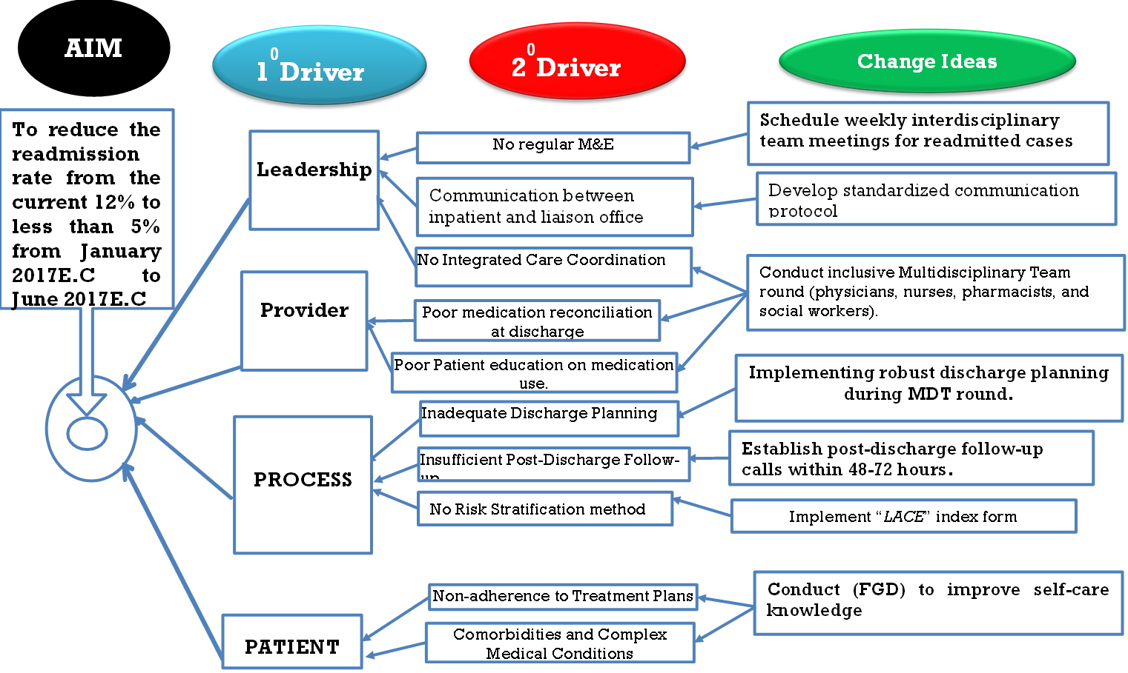
Figure 2: Driver diagram to reduce the readmission rate from the current 12% to less than 5% from January 2017E.C to June 2017E.C

List of interventions/change ideas selected by prioritization matrix for testing
- Introduce discharge planning on Multidisciplinary Team round
- Conduct (FGD) to improve self-care knowledge
- Schedule weekly interdisciplinary team meetings for readmitted cases
- Establish post-discharge follow-up calls within 48-72 hours.

MEASURES/INDICATORS
Outcome measure
- Percentage of patients readmitted to the hospital within 30 days of discharge.
Process Measures
- Proportion of inclusive Multidisciplinary Team round conducted.
- % of FGDs conducted.
- Number of meetings conducted.

IMPLEMENTATIONS OF PLAN OF PDSA
Change Idea | HOW | WHO | When | Where
Introduce discharge planning on Multidisciplinary Team rounds | The project team selected relevant staff from existing department lists and communicated the objectives. Team leads were assigned to coordinate actions, and agendas were prepared for standardized meetings. | Project Manager, Physicians, Nurses, Social Workers | At admission and daily rounds | Patient care units (ward)
Conduct FGDs to improve self-care knowledge | The project team identified patients and caregivers for FGDs, prepared discussion guides covering key topics, and ensured that sessions were conducted in private, comfortable settings to promote engagement and learning. | Nurse Educators, Case Managers | Post-discharge (within 1 week) | hospital conference rooms
Schedule weekly multidisciplinary team meetings for readmitted cases | Weekly meetings were conducted as scheduled, and minutes were recorded for action tracking. | Quality Improvement Team, Department Heads | Every Monday (9–10 AM) | Hospital administration office
Establish post-discharge follow-up calls within 48–72 hours | Staff used a standardized script to conduct follow-up calls within 48–72 hours post-discharge. Call outcomes were documented in logs. | Discharge Coordinators, Registered Nurses | Daily (8 AM–5 PM) | Dedicated call center/office

Outcome Measure data collection plan
AIM | Data source (Where) | Data collection method (how) | Time (Frequency) | Responsible for DC
To reduce the readmission rate from the current 12% to less than 5% from January 2017E.C to June 2017E.C | READMISSION Register | Observation | Monthly | MW head (Abdurro )

Process Measurements data collection plan
Process/Change idea | Data source (Where) | Data collection method (how) | Time (When) | Responsible Person
Introduce discharge planning on Multidisciplinary Team round | Round book | Attendance lists and minutes. | Jan 01, 2017E.C to Feb 30, 2017E.C | MW head (Abdurro)
Conduct (FGD) to improve self-care knowledge | FGD Attendance Log | Participant lists and feedback. | March 01, 2017 E.C to April 30, 2017E.C | MW head (Abdurro)
Schedule weekly interdisciplinary team meetings for readmitted cases | Meeting Minutes | Record attendance and outcomes. | May 01-30, 2017E.C | MW head (Abdurro)
Establish post-discharge follow-up calls within 48-72 hours. | Call Log | Document follow-up calls. | June 01-30, 2017E.C | MW head (Abdurro)

Process Measurements Performance Tracking sheet
S.No | Change Ideas/ Interventions |  |  |  | Remark
S.No | Change Ideas/ Interventions | Number/session planned | Number/session performed | % of achievement | Remark
1 | Introduce discharge planning on Multidisciplinary Team round | 44dys | 44 | 100
3 | Conduct (FGD) to improve self-care knowledge | 8 sessions | 8 | 100
4 | Schedule weekly interdisciplinary team meetings for readmitted cases | 4 sessions | 4 | 100
5 | Establish post-discharge follow-up calls within 48-72 hours. | 22 days | 22 | 100

Do of PDSA
AIM | QIP: To reduce the readmission rate from the current 12% to less than 5% from January 2017E.C to June 2017E.C |  | Time: Monthly
To reduce the readmission rate from the current 12% to less than 5% from January 2017E.C to June 2017E.C | Numerator, Denominator & outcome Indicator |  | 30-Jan-17E.C | 30-Feb-17E.C | 30-Mar-17E.C | 30-Apr-17E.C | 30-May-17E.C | 30-June-17E.C
 | Numerator | Number of readmissions within a defined time period | 1 | 3 | 3 | 3 | 1 | 2
 | Denominator | Total number of discharges during the same time period | 135 | 88 | 88 | 109 | 90 | 106
 | Indicator | Readmission Rate | 0.7 | 3.4 | 3.4 | 2.7 | 1.1 | 1.8

RESULTS
The quality improvement project aimed to reduce the hospital readmission rate from a baseline of 12% to below 5% over a six-month period (January to June 2017 E.C.). At baseline, data collected from July to December 2016 showed a gradually increasing trend in readmissions—starting at 7% in July and climbing to 16% by December. Despite efforts to maintain care standards, this increasing rate indicated a gap in effective discharge planning and post-discharge follow-up. The average readmission rate over the baseline period was 12%, which served as a reference median for measuring improvement.
To address the issue, PDSA Cycle 1 was implemented in January 2017, which introduced discharge planning as part of the routine multidisciplinary team (MDT) rounds. This strategic intervention had an immediate and profound impact: the readmission rate sharply declined from 16% in December to 0.7% in January. In the following months, the rate remained significantly below baseline, with 3.4% in both February and March. This indicated that incorporating discharge planning into MDT rounds helped ensure patients were clinically ready for discharge and received adequate follow-up plans, which prevented unnecessary readmissions.
Building on this momentum, two additional PDSA cycles were executed. PDSA cycle 2 involved conducting focused group discussions (FGDs) with staff in February to identify remaining gaps and promote staff engagement in the QI process. PDSA cycle 3, rolled out in April, introduced weekly MDT meetings specifically to review readmitted cases and identify preventable causes. These combined efforts resulted in further improvements: readmission rates dropped to 2.7% in April, 1.1% in May, and slightly rose to 1.8% in June—but still remained well below the target of 5%. Overall, the sustained reduction demonstrates the effectiveness of a structured, team-based approach to discharge planning and follow-up care.

Baseline

Figure 3: Run chart with Multiple PDSA to reduce the readmission rate from the current 12% to less than 5% from January 2017E.C to June 2017E.C

DISCUSSION
The results of this quality improvement project clearly demonstrate that structured and multidisciplinary interventions can significantly reduce hospital readmission rates. Initially, the trend of rising readmission—from 7% to 16%—indicated gaps in discharge processes, follow-up care, and clinical coordination. The consistently high baseline median of 12% further emphasized the need for a systematic change. The success of PDSA 1 in January 2017, which introduced discharge planning during MDT rounds, suggests that early and coordinated planning before discharge plays a vital role in ensuring patient readiness and continuity of care after hospitalization.
Furthermore, the sharp and sustained drop in readmission following PDSA 1 underscores the importance of real-time, team-based discharge decisions. However, while the initial drop to 0.7% was significant, a slight rebound to 3.4% in February and March indicated that discharge planning alone was not sufficient to maintain long-term improvement. Therefore, the implementation of PDSA 2 (conducting FGDs) was critical in identifying operational challenges and engaging frontline staff in the change process. These discussions helped uncover workflow gaps and improved staff ownership of discharge protocols.
The final intervention, PDSA 3, focused on strengthening accountability and case-based learning through weekly MDT reviews of readmitted cases. This not only helped identify preventable causes of readmission but also encouraged continuous improvement and shared responsibility among clinical teams. The continued decline in readmission rates to as low as 1.1% in May and 1.8% in June reflects the effectiveness of combining clinical protocols with staff engagement and continuous learning. This project highlights how layered interventions—rooted in teamwork, communication, and data-driven decision-making—can achieve and sustain meaningful outcomes in hospital quality improvement.

LESSONS LEARNT
The lessons learnt from the readmission rate reduction QI project:
- Multidisciplinary collaboration is key: Integrating discharge planning into regular MDT rounds ensured shared decision-making, improved communication among care teams, and enhanced patient preparedness for discharge.
- Early discharge planning leads to better outcomes: Starting discharge planning before the day of discharge helped identify potential risks, clarify responsibilities, and reduce the likelihood of preventable readmissions.
- Continuous staff engagement enhances success: Conducting focused group discussions (FGDs) created a platform for staff to share insights, challenges, and solutions—boosting ownership and alignment with the QI goals.
- Data-driven decisions improve accountability: Weekly MDT reviews of readmitted cases fostered a culture of learning from errors, identifying system gaps, and continuously refining care processes based on real-time data.
- Layered interventions produce sustainable results: A combination of structural changes (PDSA 1), staff involvement (PDSA 2), and case analysis (PDSA 3) created a strong foundation for sustained improvement.
- Simple interventions can have a big impact: Despite limited resources, the project achieved a drastic reduction in readmissions through low-cost, practical strategies centered on teamwork and communication.

CONCLUSION
This quality improvement project successfully reduced the hospital readmission rate from a baseline of 12% to below 2% within six months, achieving well beyond the target of less than 5%. The significant and sustained decline in readmission rates was the result of strategic, team-based interventions implemented through three PDSA cycles. Key actions included incorporating discharge planning into MDT rounds, engaging staff through focused group discussions, and conducting weekly multidisciplinary reviews of readmitted cases. These interventions enhanced communication, accountability, and clinical decision-making across departments.
The project demonstrates that targeted, low-cost strategies can yield impactful results when guided by data, collaboration, and continuous learning. More importantly, it highlights the value of building a culture of quality and shared responsibility in improving patient outcomes. The success of this initiative provides a strong model for other departments aiming to reduce readmissions and improve continuity of care.

REFERENCES
- Melesse B. The determinants of patient waiting time in the general outpatient department of Debre Markos and Felege Hiwot hospitals in Amhara. Glob J Med public Heal. 2017;6(5):2.
- Institute of Medicine (IOM). (2001). Crossing the Quality Chasm: A New Health System for the 21st Century. National Academies Press.
- Langley, G. J., Moen, R., Nolan, K. M., Nolan, T. W., Norman, C. L., & Provost, L. P. (2009). The Improvement Guide: A Practical Approach to Enhancing Organizational Performance (2nd ed.). Jossey-Bass.
- Berwick, D. M. (2008). "The Science of Improvement." JAMA, 299(10), 1182–1184.
- World Health Organization (WHO). (2018). Quality of Care: A Process for Making Strategic Choices in Health Systems. WHO Press.
- Bates, D. W., & Gawande, A. A. (2003). "Improving Safety with Information Technology." New England Journal of Medicine, 348(25), 2526–2534.
- Kotter, J. P. (1996). Leading Change. Harvard Business Review Press.
- Deming, W. E. (1986). Out of the Crisis. MIT Press.
- Donabedian, A. (1988). "The Quality of Care: How Can It Be Assessed?" JAMA, 260(12), 1743–1748.
- NHS Institute for Innovation and Improvement. (2008). Quality and Service Improvement Tools.
- Berwick, D. M., Nolan, T. W., & Whittington, J. (2008). "The Triple Aim: Care, Health, and Cost." Health Affairs, 27(3), 759–769.

